Title: Importing Tabular Data into QGIS

What you will learn:
- Import tabular data into QGIS
- Create a vector layer
- Join and edit attribute tables
- Interpolate point data to raster
- Style and label point vectors
- Style a raster

Resources:
- Data for this exercise is in the data6 folder (UNZIP the folder after downloading).
Laboratory Exercise: In this exercise, you are going to import data from a table with daily temperature recorded in the metrological stations across Central Illinois. From this data, you will produce a map that shows how the daily temperature changes in space.

Deliverables:
- Map of metrological stations with the daily temperature shown and the spatial extent of each station.
- Answer to Part 5 step 6 question.

Procedure:

In the folder data6, you will find two Excel files:

- Central_IL_stations.xlsx – contains the geographic information of the metrological stations.
- Temp_May2010.xlsx – contains the daily temperature (in tenths of ºC) for May 2010 for the different stations.

It is always good practice to check the contents of the spreadsheet before starting any processing. This way you become familiar with the information in the spreadsheets and will understand the instructions better. Which of the two files has the coordinates? Notice that some values for temperature are missing.

The procedure of this exercise will follow the workflow in Figure 1.

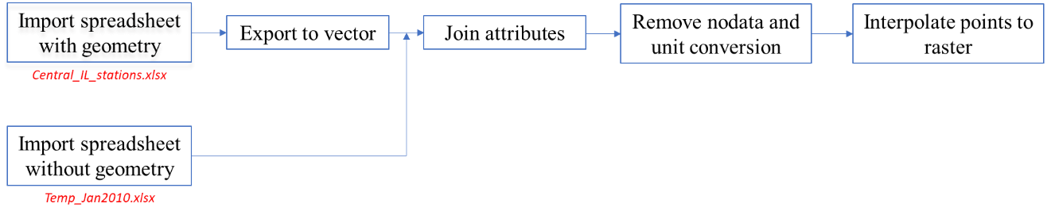
Figure 1 Workflow for this exercise

Part 1 – Import Spreadsheets

There are different ways to import tabular data in QGIS:
- From the main menu: Layer – Add Layer – Add Delimited Text Layer…
- From the main menu: Layer – Add Layer – Add Spreadsheet Layer…

We will use the second option for which we need to install the Spreadsheet Layers plugin. You will only do this one time. Once you have installed the plugin, the Add Spreadsheet Layer option will be available every time you select the Add Layer.

1. Open QGIS.

2. From the main menu: Plugins – Manage and Install Plugins. Select the “All” tab (left side) and scroll to find Spreadsheet Layers. Click and install (Figure 2) and close the Plugins window.

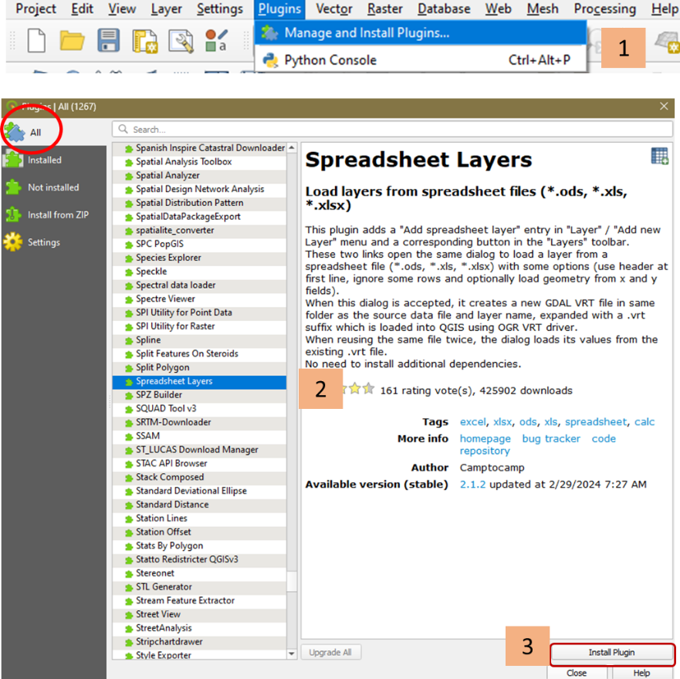
Figure 2. Installing the Spreadsheet Layer plugin

3. Check that it was properly installed. From the main menu select Layer – Add Layer. Add Spreadsheet Layer should now be available (Figure 3).
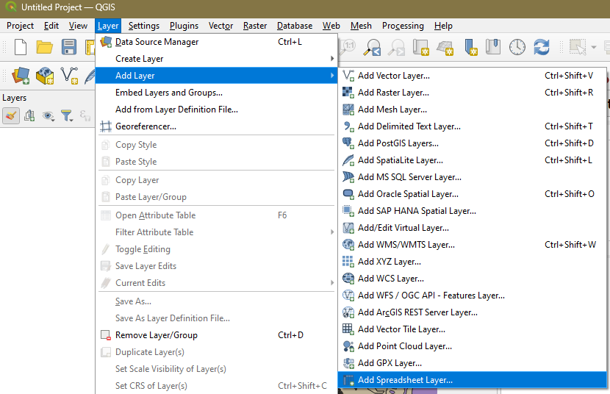
Figure 3. Add Spreadsheet Layer option added

4. Import Central_IL_stations.xlsx:
- From the main menu: Layer – Add Layer – Add Spreadsheet Layer…
- Browse to Central_IL_stations.xlsx. The Create a Layer from a Spreadsheet File window will open (Figure 4). Complete the dialogue boxes according to the information in Figure 4 and take note of the following:
  - Layer name = Temperature Stations
  - Geometry should be checked – since the data has coordinates.
  - X field = Longitude and Y field = Latitude
  - Make sure that the correct data type for the fields is chosen. For instance, Sta should be an “Integer”, the Station Name should be a “String”, and the rest are “Real”
  - Leave the rest of the fields as is.
- Click OK. The data points should appear in your map canvas.
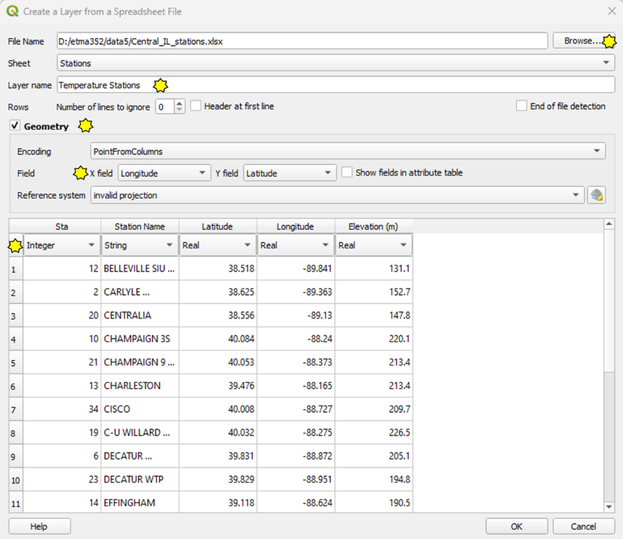
Figure 4. Create a layer from a spreadsheet file with geometry

5. Import Temp_May2010.xlsx: Add the spreadsheet in the same way but without geometry since it does not contain coordinates (see Figure 5 for entries). Geometry should be unchecked, and the correct data type should be used. Click OK when done.

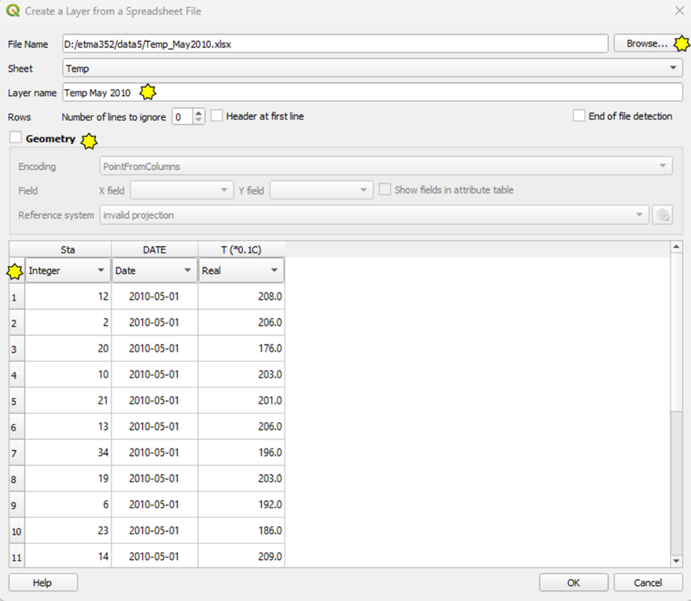
Figure 5. Create a layer from a spreadsheet file without geometry
QGIS should look something like in Figure 6. The tables that you added should appear on the Layers panel and the Temperature stations should show as dots on the map canvas. If you do not see the dots, right-click on the Temperature Stations layer and choose Zoom to Layer(s). You can also click the Zoom Full icon on the toolbars.
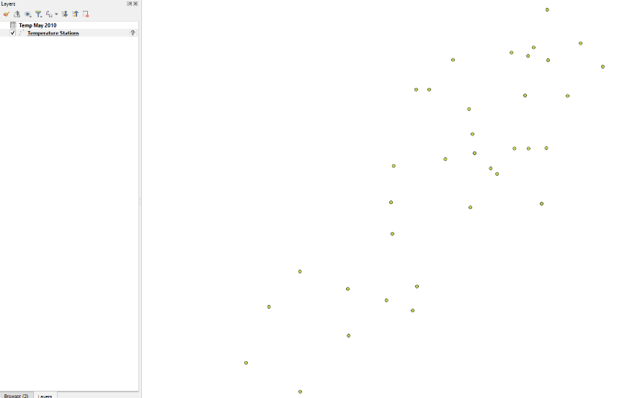
Figure 6. Imported data from spreadsheets.
Part 2 – Convert spreadsheet to vector layer

You have now converted the spreadsheet tables into layers in QGIS as follows:
- Central_IL_stations.xlsx → Temperature Stations
- Temp_May2010.xlsx → Temp May 2010

We will now convert the Temperature Stations layer (formerly Central_IL_stations.xlsx) into a vector layer with point geometry. We will also assign the proper projection of the layer and the map.

1. Right-click on the Temperature Stations layer on the Layers panel and choose Export – Save Features As… (Figure 7).

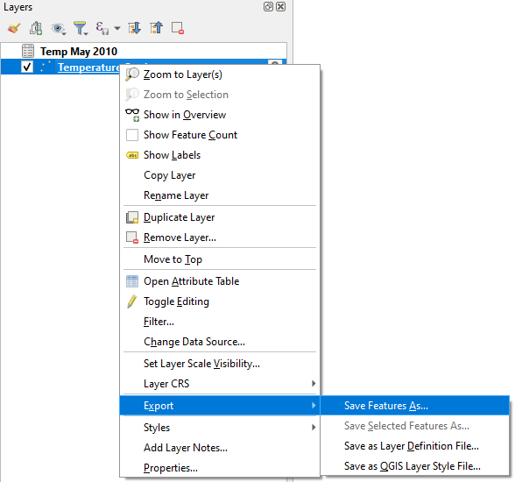
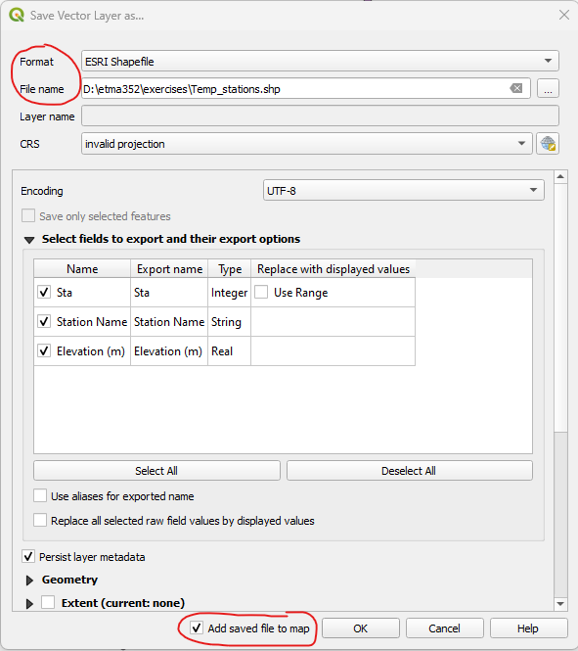
Figure 7. Exporting layers
The Save Vector Layer as… window will open.

2. Fill up the following fields and leave the rest as they are:
- Format: ESRI Shapefile
- File name: Browse to where you want to save the file and name it “Temp_stations”
- Ensure the Add saved file to map option is checked (see Figure 8) before clicking OK.
- Say OK to transformation questions (if any).

3. Right-click on the Temperature Stations layer from the Layers panel then choose Remove Layer (Figure 9). You do not need this layer anymore since you have converted it into a vector layer. You will be using the vector layer (Temp_stations) for the rest of the exercise. Make it a habit to remove layers that are no longer needed to maintain an organized workspace free of clutter.
Figure 8. Saving the vector layer

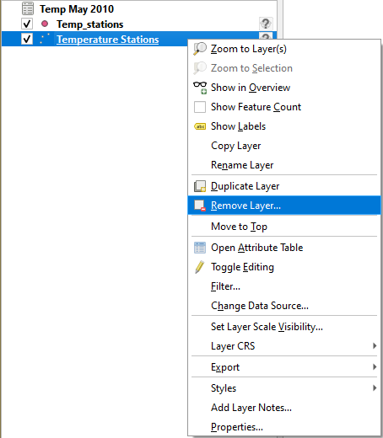
Figure 9. Removing original layers after processing

4. Set the layer and project projections:

The data for this exercise were downloaded from the National Oceanic and Atmospheric Administration (NOAA). NOAA uses the North American Datum of 1983 (2011) (aka EPSG:6319) as its coordinate reference system (CRS). We will inform QGIS that this is the appropriate projection of the newly created shapefile.

- On the Layers panel, right-click on the Temp_stations layer then choose Properties – Source (Figure 10).
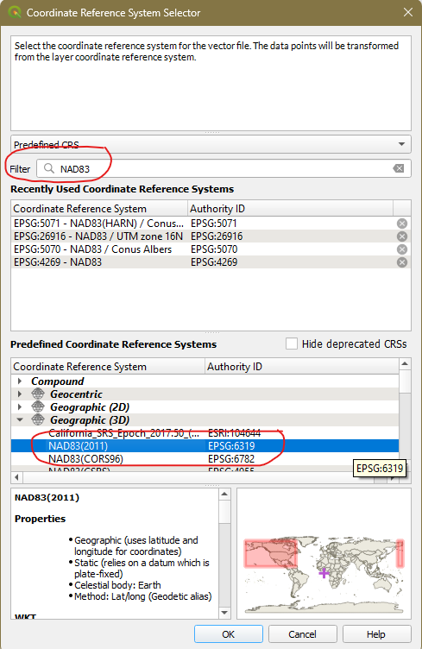
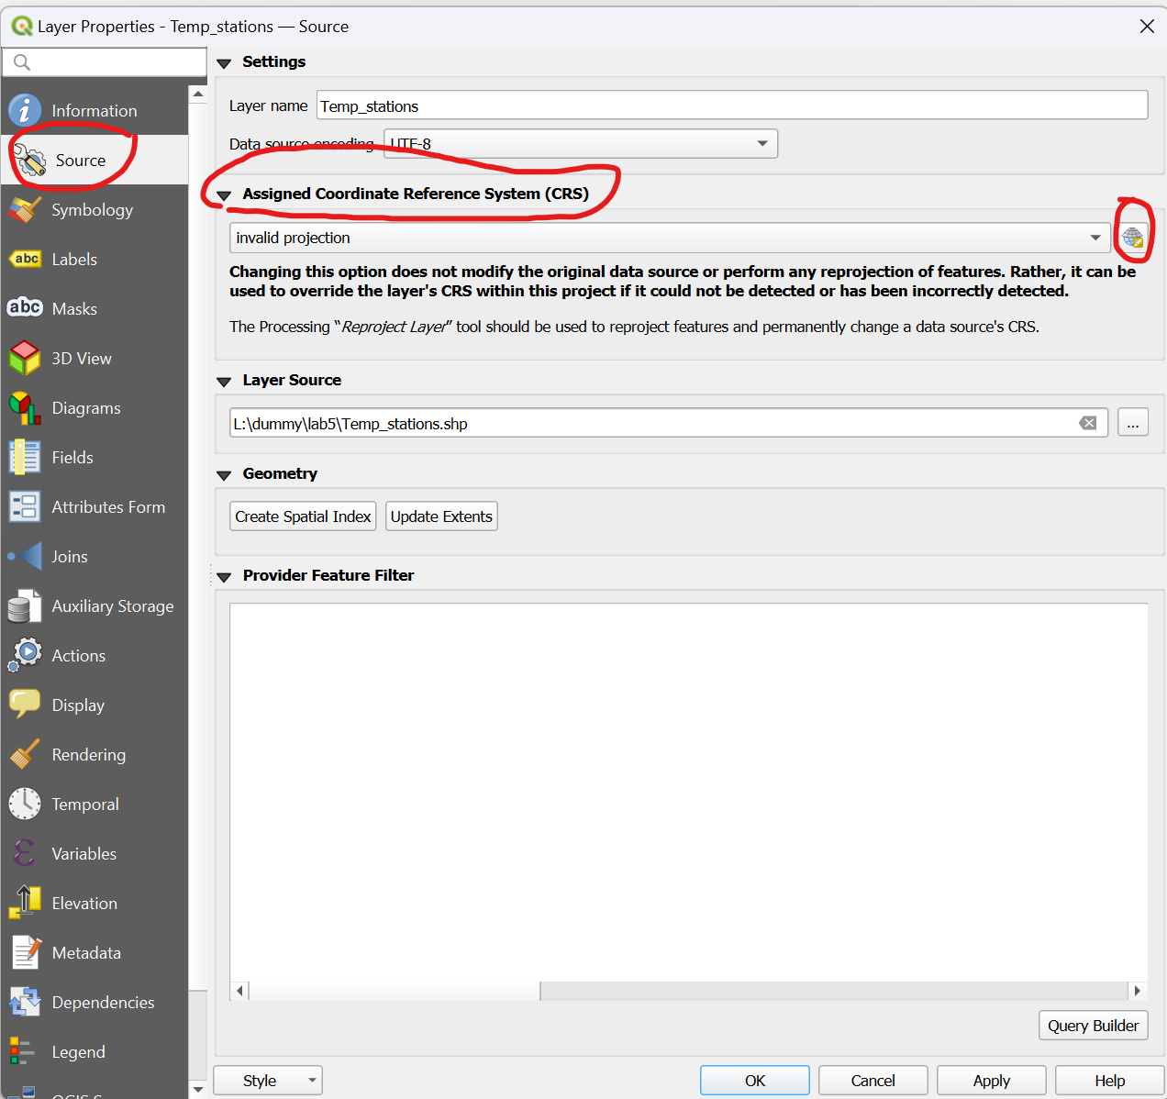
Figure 10. Layer Properties window
- Under Assigned Coordinate Reference Systems (CRS), click the Select CRS icon next to the dropdown arrow (Figure 10). This will open the Coordinate Reference System Selector window (Figure 11).
  - On the Filter field, type NAD83 or EPSG:6319. On the Predefined Coordinate Reference Systems field, expand Geographic 3D and look for NAD83. Use NAD83(2011) (Figure 11). Click OK to set the CRS.
  - Click OK to close the Properties window.
- Check that the layer was properly projected. Hover the mouse over the Temp_stations layer on the Layers panel. The CRS should show as EPSG:6319 → 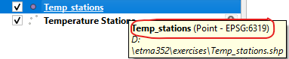
Figure 11. Selecting the CRS

Although the Temp_stations layer is now in EPSG:6319 projection, the QGIS map canvas still uses EPSG:4326 (see lower right corner of QGIS). To visualize all layers in EPSG:6139 we have to change the QGIS Project properties.

- On the main menu choose Project – Properties. The Project Properties window will open. Click CRS tab (left side of window)

- On the Recently Used Coordinate Systems, EPSG:6319 - NAD83(2011) should be already listed (Figure 12). Select it and click OK to close.

- You can save your work at this point. Give it whatever file name you prefer. Make it a habit to save your work regularly.

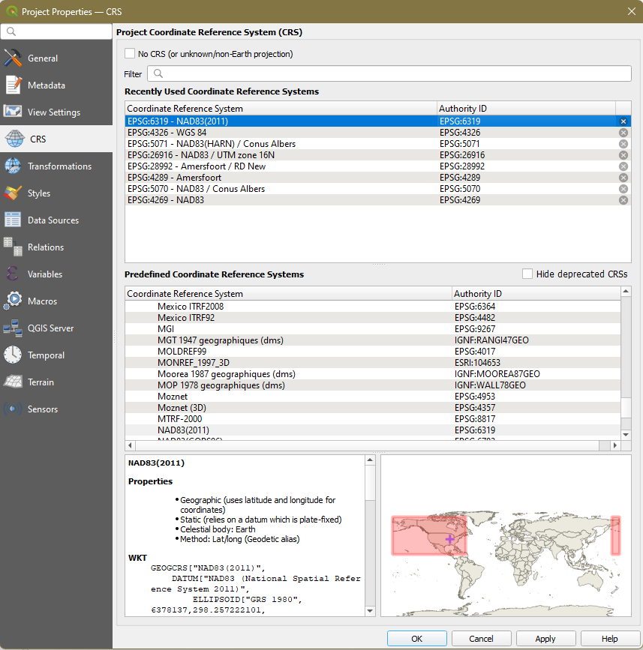
Figure 12. Change the on-the-fly reprojection of the project

6. Check that the CRS at the lower right corner of QGIS changed to EPSG:6319.

Part 3 – Join Attribute Tables

The locations of the temperature stations and the temperature data are still on separate tables. For further analysis, we need to combine them into one vector layer. In GIS terms, this is called a JOIN operation. We can only join tables if they have a common column which in our case is the station number under the column, “sta”.

1. Check the attribute tables of the two layers on the Layer panel: Right-click – Open Attribute Table. Notice that both layers have the same “sta” columns. This means that we can join the two attribute tables using “sta” as the field of reference.

2. Close the attribute tables

3. Right-click on the Temp_stations layer and choose Properties.

4. From the left panel, click the Joins tab

5. Click the add new join button located at the lower part of the window.

6. Complete the Add Vector Join window as shown in Figure 13. The common field (column) is “sta”. We will only join the temperature field (Joined Field = T(*0.1C)) and give the column the prefix Temp_.

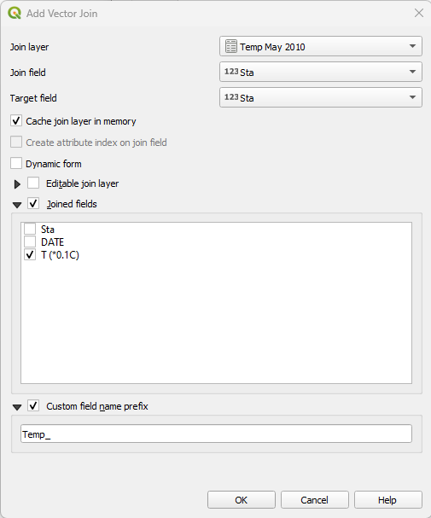
Figure 13. Add vector join entries
7. Click OK.

8. Click OK to perform the Join operation.

9. Check the attribute table of Temp_stations. The temperature column should have been added so that you have now four columns in the table.

10. Close the attribute table and save your work.

Part 4 – Edit the Joined Attribute Table

The joined attribute table needs two corrections: (1) features with missing data (NULL) need to be removed, and (2) the temperature needs to be converted to the right units. Right now, the temperature values are expressed as a tenth of ºC. This must be multiplied by 0.1 to get the correct units (ºC).

1. Right-click on Temp_stations and open the attribute table.

2. Click on row numbers with NULL or no values for temperature while keeping the Ctrl key pressed. This will allow you to select multiple columns. There should be four rows with missing values (Figure 14).
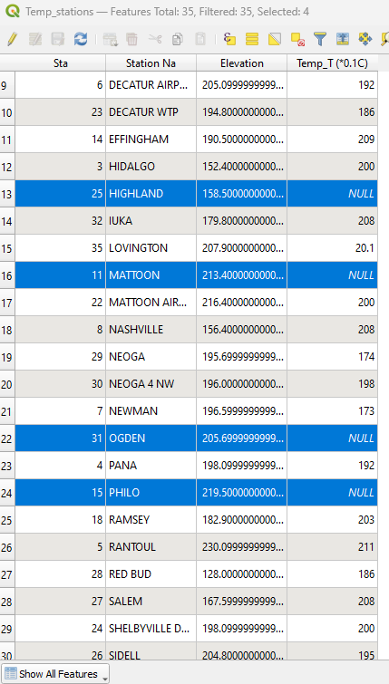
Figure 14. Select features with missing values
3. On the toolbar atop the attribute table, click the editing tool to toggle the editing mode.

4. Click the delete button to delete the selected features (rows). NOTE: sometimes the attribute table minimizes after deleting something. Hover the mouse on the QGIS icon on the taskbar of your PC and click the attribute table to maximize it. Save the attribute table by clicking .

We will now convert the temperatures from 0.1ºC to ºC.

5. Click the new field button to add a new column to the table. Fill in the Add Field dialogue as shown in Figure 15. The Name = T (C); Type = Decimal number (real); Length is the number of digits = 3; and Precision is the number of decimal places = 1.

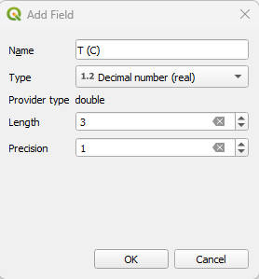
Figure 15. Add field dialogue
6. Click OK to proceed. Save the attribute table again and then close it.

7. Open the attribute table again. Notice that it shows an extra column with NULL values. We are going to propagate this column with temperature values with correct units.

8. Click the dropdown arrow to the left of the = sign below the toolbar and select T (C) → (see Figure 16).

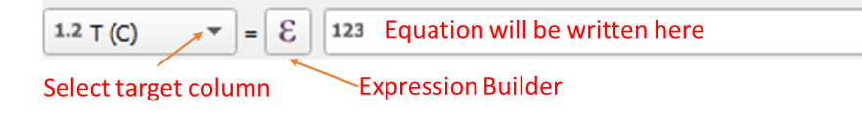
Figure 16. Writing the equation for the new field
9. To calculate the correct values of T (C), click to the right of the = sign to open the Expression Builder. This window allows you to write the equation to compute the values of the selected column, in this case T(C).

10. Write the equation on the Expression field by double-clicking the icons instead of typing them (except for numbers). We need to write the equation Temp_T (*0.1C) * 0.1 as follows (Figure 17):
- Expand Field and Values and double-click Temp_T (*0.1C).
- Using the set of operations below click instead of typing it.
- Type 0.1
- Click OK

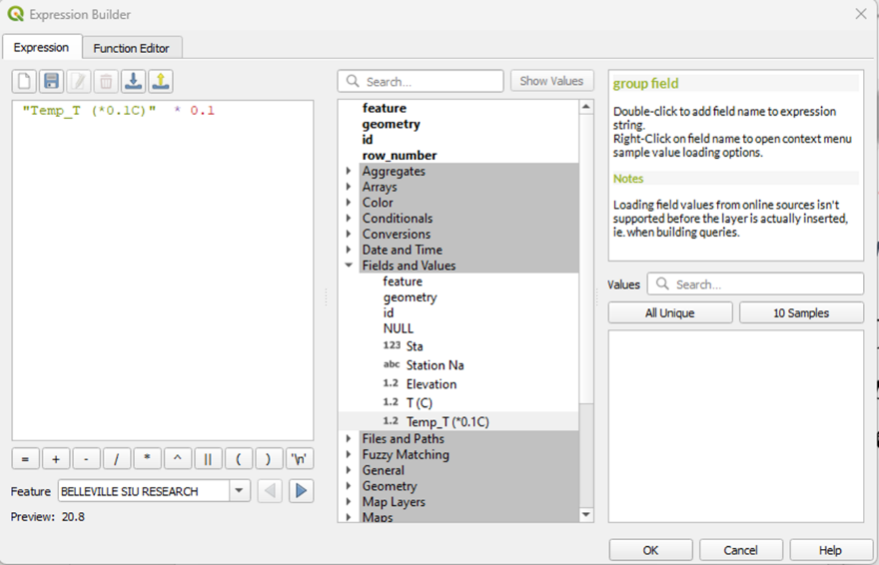
Figure 17. Expression builder to do calculations

11. Check that the equation is correctly written on the filed above the table (Figure 17)

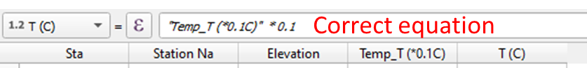
Figure 18. Equation to compute values in the T(C) column.
12. Click Update All (next to the equation field) to perform the calculation for all features. Correct values for temperature are now reflected in the T (C) column.

13. Click on the editing icon to toggle back to non-editing mode. Save the changes and close the attribute table.

Part 5 – Interpolate Point Features to Raster

The temperature values from the meteorological stations are point measurements. We are now going to spatially interpolate the values to cover an area.

1. From the main menu choose Raster – Analysis – Grid (Nearest Neighbor) (Figure 18). 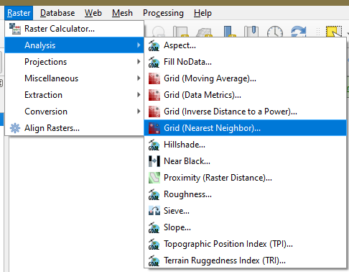
Figure 19.Interpolate to raster using nearest neighbor
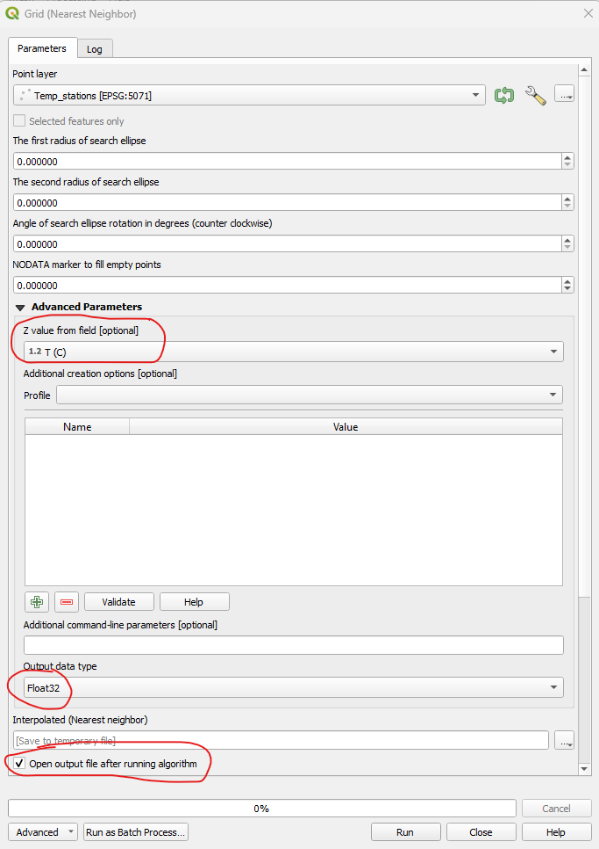
2. On the Grid window, scroll down and specify the following (Figure 19):
- Z value from the field = T (C)
- Output data type = Float32
- Check “Open output file after running algorithm”
- Keep the rest of the fields at default.

3. Click Run to proceed

4. Close window

5. Repeat the interpolation (steps 1 to 4) using the Raster – Analysis – Grid (Inverse Distance to a Power) (aka IDW) algorithm.

6. You now have two raster maps in the Layers panel, one interpolated using the nearest neighbor method and one using IDW. Describe the difference in the resulting raster between the two interpolation methods in your lab report. Insert your answer in your lab report.
Figure 20. Interpolate to raster

Part 6 – Styling the Results

For the final map, we will only show the Temp_stations and Interpolated (IDW) layers. The map should show the stations (as points), the name of the station, and the temperature. This will overlay (lay over) the interpolated raster.

1. On the Layers panel, drag the Temp_stations so that it is positioned above the raster. The points should be visible over the raster on the map canvas.

2. Styling the Temp_stations:
- Atop the Layers panel, click the Open the Layer Styling icon.
- On the Layer Styling panel (right side), select the layer Temp_stations using the dropdown arrow.
- Click the Simple Marker component and set the Fill color to black and the Size to 2.8 (Figure 21).
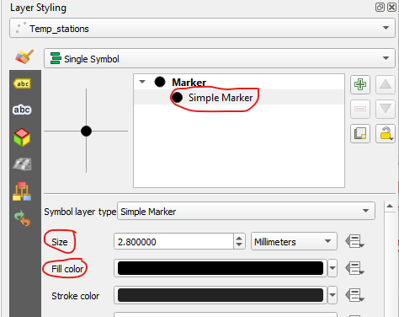
Figure 21. Modifying the point marker of the stations
- Switch to the Labels tab by clicking on the right edge of the Layer Styling panel.
- Click the dropdown arrow and change from No Labels to Single Labels
- Set the Value to the Station Name (or Station Na).
- Below the Value are tabs to style the label: 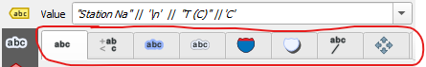. Click each tab to explore their functionalities.
- Click the Text tab 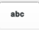 and change the Font to Calibri with a Style of Bold and a Size of 10.
- Notice that the names are all upper case. Using the Formatting tab , change the Type case to Title case and the Alignment to center (Figure 22).

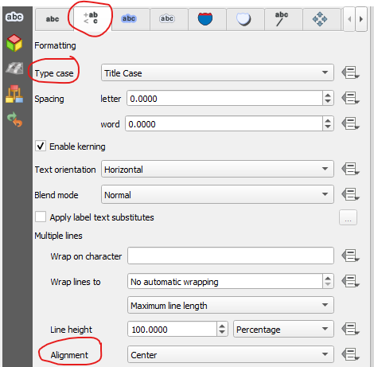
Figure 22. Editing the labels.
- We will now add the temperature values to the station names. Click the Expression button (beside the Value field) to open the Expression Builder window.
- Use (by clicking) the String Concatenation operator and the New Line operator to add the T (C) values to the label on the second line. When you click 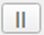 and they will appear on the expression field. Write your labeling expression that reads “Station Na” || ‘\n’ || “T (C)” || ‘ C’ (Figure 23). T (C) can be found when you expand “Fields and Values”. Double-click it to write it on the expression field. Type the rest of the characters. Check that there are no typos.
- Click OK

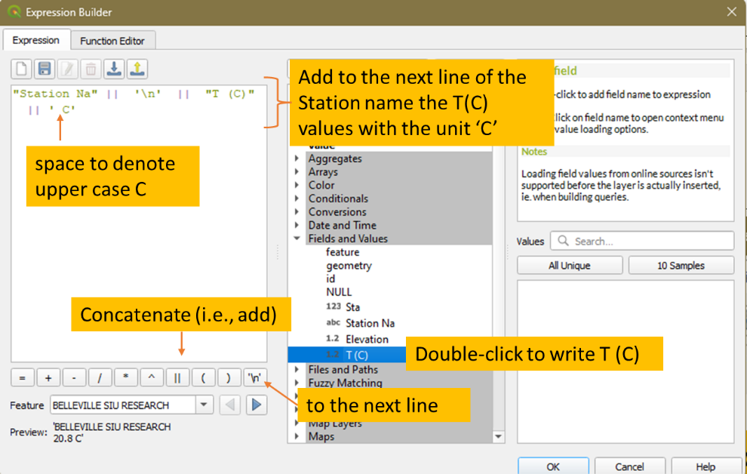
Figure 23. Adding the temperature values to the station name.
- You should now see the names of the stations (near dots) and the temperature under them (Figure 24).

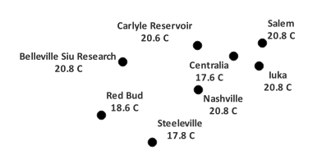
Figure 24. Example of how the label should look like

3. Let us now style the Interpolated (IDW) raster. On the Layer Styling panel, change the target layer to Interpolated (IDW) and change the rendering from default Singleband gray to Singleband pseudocolor. We will modify the color scheme by changing the following (see Figure 24):
- Color ramp = Spectral then click Classify.
- Mode = Quantile
- Blending mode = Multiple

You can also experiment with the different styling options to see how they change the appearance of your map.

4. Save your work.

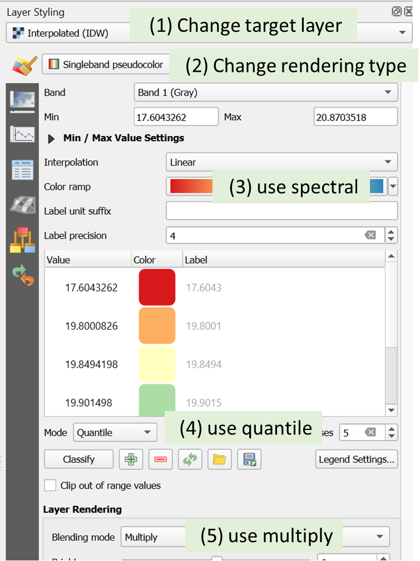
Figure 25. Styling the raster

4. Before creating a printable map, right-click on one of the layers on the Layers panel and choose Zoom to Layers or simply click . This will give you zoom in view of the layers which will transfer to the print layout.
5. Click the New Print Layou icon 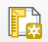 and create a printable map (see example in Figure 26). Follow the steps from the previous lab exercise. Feel free to style your printable map but make sure to insert the following elements:
- Map Title: Daily Average Temperature May 2010
- Your name and date
- North arrow
- Scale bar
6. Export your map as an image (*.PNG) and as a PDF file following the instructions in the previous lab.
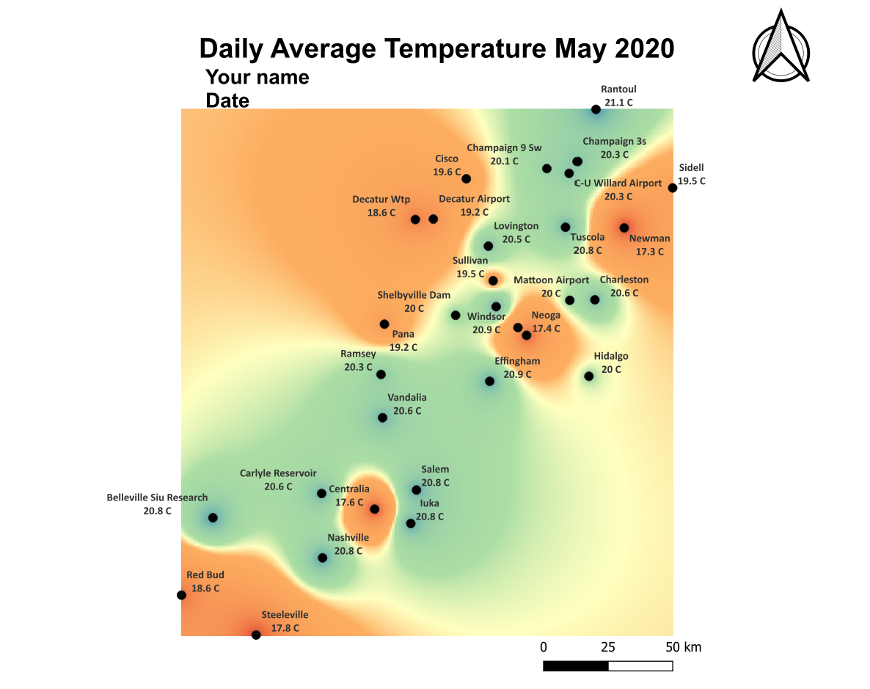
Figure 26. Example of final map

